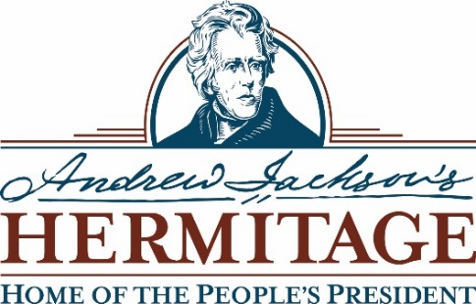

Position Title: Assistant Garden Manager
Reports To: Historic Garden Manager
Hour per Week: 40 hours
Exempt Status: Non-exempt
Anticipated start: February 2020

Job Objective
The Assistant Garden Manager helps preserve and maintain the Hermitage Garden in a manner that is both historically accurate and aesthetically pleasing, while striving to educate and inspire the public through the Hermitage Garden’s history and plants.
Principal Duties and Responsibilities
- Maintain, with the garden team, the garden in a manner consistent with a National Historic Landmark Presidential Site. This includes but is not limited to; weeding, watering, monitoring, seeding, transplanting, trellising, and labeling plant material. In addition, the AGM will monitor and upkeep pathways and other key garden infrastructure.
- Work closely with the Historic Garden Manager to develop historically appropriate annual planting plans for the Hermitage Garden, non-historic planting beds, and demonstration crops.
- Develop a consistent and high-quality growing program.
- Coordinate with the Historic Garden Manager to plan and maintain best greenhouse practices.
- Responsible for projecting short- and long-term seed and plant budgets, plant and seed orders, and maintaining a quarterly inventory of all plant stocks and inputs.
- Manage all interior plants, and monitor the watering, aesthetic, and upkeep of those plantings.
- Lead annual plant sales; including plant selection, inventory, signage, marketing calendar, set-up, sales projections, and scheduling.
- Assist in forecasting soil improvements and amendment schedules.
- Implement pest and disease monitoring and management plans.
- Help with the care and maintenance of trees and shrubs in the historic and public areas.
- Assist with installation and maintenance for all seasonal plantings and decorations in the public and administrative areas of the Hermitage.
- Give tours of the garden, speak to groups about the garden, and work with volunteers and education and interpretation staff to develop and host garden programming.
- In the absence of the Historic Garden Manager supervises garden staff and coordinates volunteers.
- Manage all work with an eye to best practices, and handle additional duties as assigned.

Education/Training
Minimum two-year degree in horticulture or landscape management, or equivalent on-the-job training.

Experience, Skills, and Abilities Requirements
- One to three years’ experience growing plants, preferable from seed.
- One to three years’ experience working in a public or historic garden.
- Greenhouse growing/management experience.
- Broad knowledge of sustainable agriculture/horticulture best practices.
- Industry standard garden tool knowledge, proficiency, and upkeep.
- Demonstrate excellent teamwork skills and good interpersonal skills.
- Knowledge of irrigation systems and familiarity with grounds equipment preferred.
- Experienced with Microsoft Word, Excel, and Outlook.
- Must present a professional demeanor and appearance and maintain confidentiality.
- Physical Requirements: Ability to perform moderate physical work exerting up to 30 pounds of force unassisted; take responsibility for hydration; prioritize personal and team safety; stoop, bend, climb, and lift; walk multiple miles during a shift; stand for long periods of time; and work outdoors in all weather conditions and extremes.

Andrew Jackson’s Hermitage: Home of the People’s President is one of the largest and most visited presidential homes in the United States. Opened as a museum in 1889, it is one of the nation’s oldest presidential sites, drawing more than 219,000 visitors each year. Located 12 miles northeast of downtown Nashville, The Hermitage is a 1,120-acre National Historic Landmark with 27 restored buildings, 12 dating to Jackson’s ownership, including his 1836 mansion and tomb, slave cabins, garden, and the church he had constructed for his beloved wife, Rachel. In the Andrew Jackson Center, guests can experience Andrew Jackson: Born for a Storm, an interactive exhibit about the life and profound impact of our seventh president on the history of the United States. Admission is free for active duty military and half-price for veterans. For more information, visit www.thehermitage.com.
To apply for the position, please send your resume and cover letter to Sarah Edmonds, Historic Garden Manager, sedmonds@thehermitage.com.

